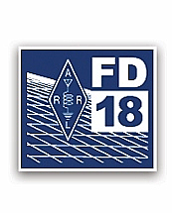

**2018**

W4CAE

**Field Day Packet**

**June 23 & June 24**

**Hours: 2:00 pm Sat – 2:00 pm Sun**

**Westin Lake Campground near Ft. Jackson**

**Table of contents**

**NATO Phonetic Alphabet................................... 1**

**Welcome Station Chairperson........................... 2**

**2018 W1AW FD Bulletin Schedule.................... 3**

**NATO Phonetic Alphabet…............................... 4**

**Calling CQ & Responding.................................. 5**

**Band Plan …........................................................ 6**

**ARRL 2018 Field Day Rules ….......................... 7**

**2018 ARRL Field Day**

Thank you for agreeing to be a Station Chairperson. I hope your experience is fun and rewarding.

The purpose if Field Day is to learn about portable operation in less than ideal conditions but do not put a greater importance on it that it deserves. In other words, relax, don't s sweat the small things and take time out to smell the hamburgers.

The Exchange this year is **5A South Carolina (SC)**

Your duties are to supervise the station, not to operate it all the time. Make sure that you are on hand at shift changes to help new operators to your station and solicit others who are looking for some place to help.

If something goes wrong, contact the Field Day chairman, Dan Cunningham K9DBC.

The site VHF frequency will be 146.400 simplex.

Remember: We will be operating from 2:00 pm EDT (1800 UTC) on Saturday until 2:00 pm EDT (1800 UTC) on Sunday.

We WILL have a Get On the Air (GOTA) station for folks to use, and those who are operating will need to take a break from time to time. You will have the opportunity to make QSO’s even if you don’t bring your own equipment!!!

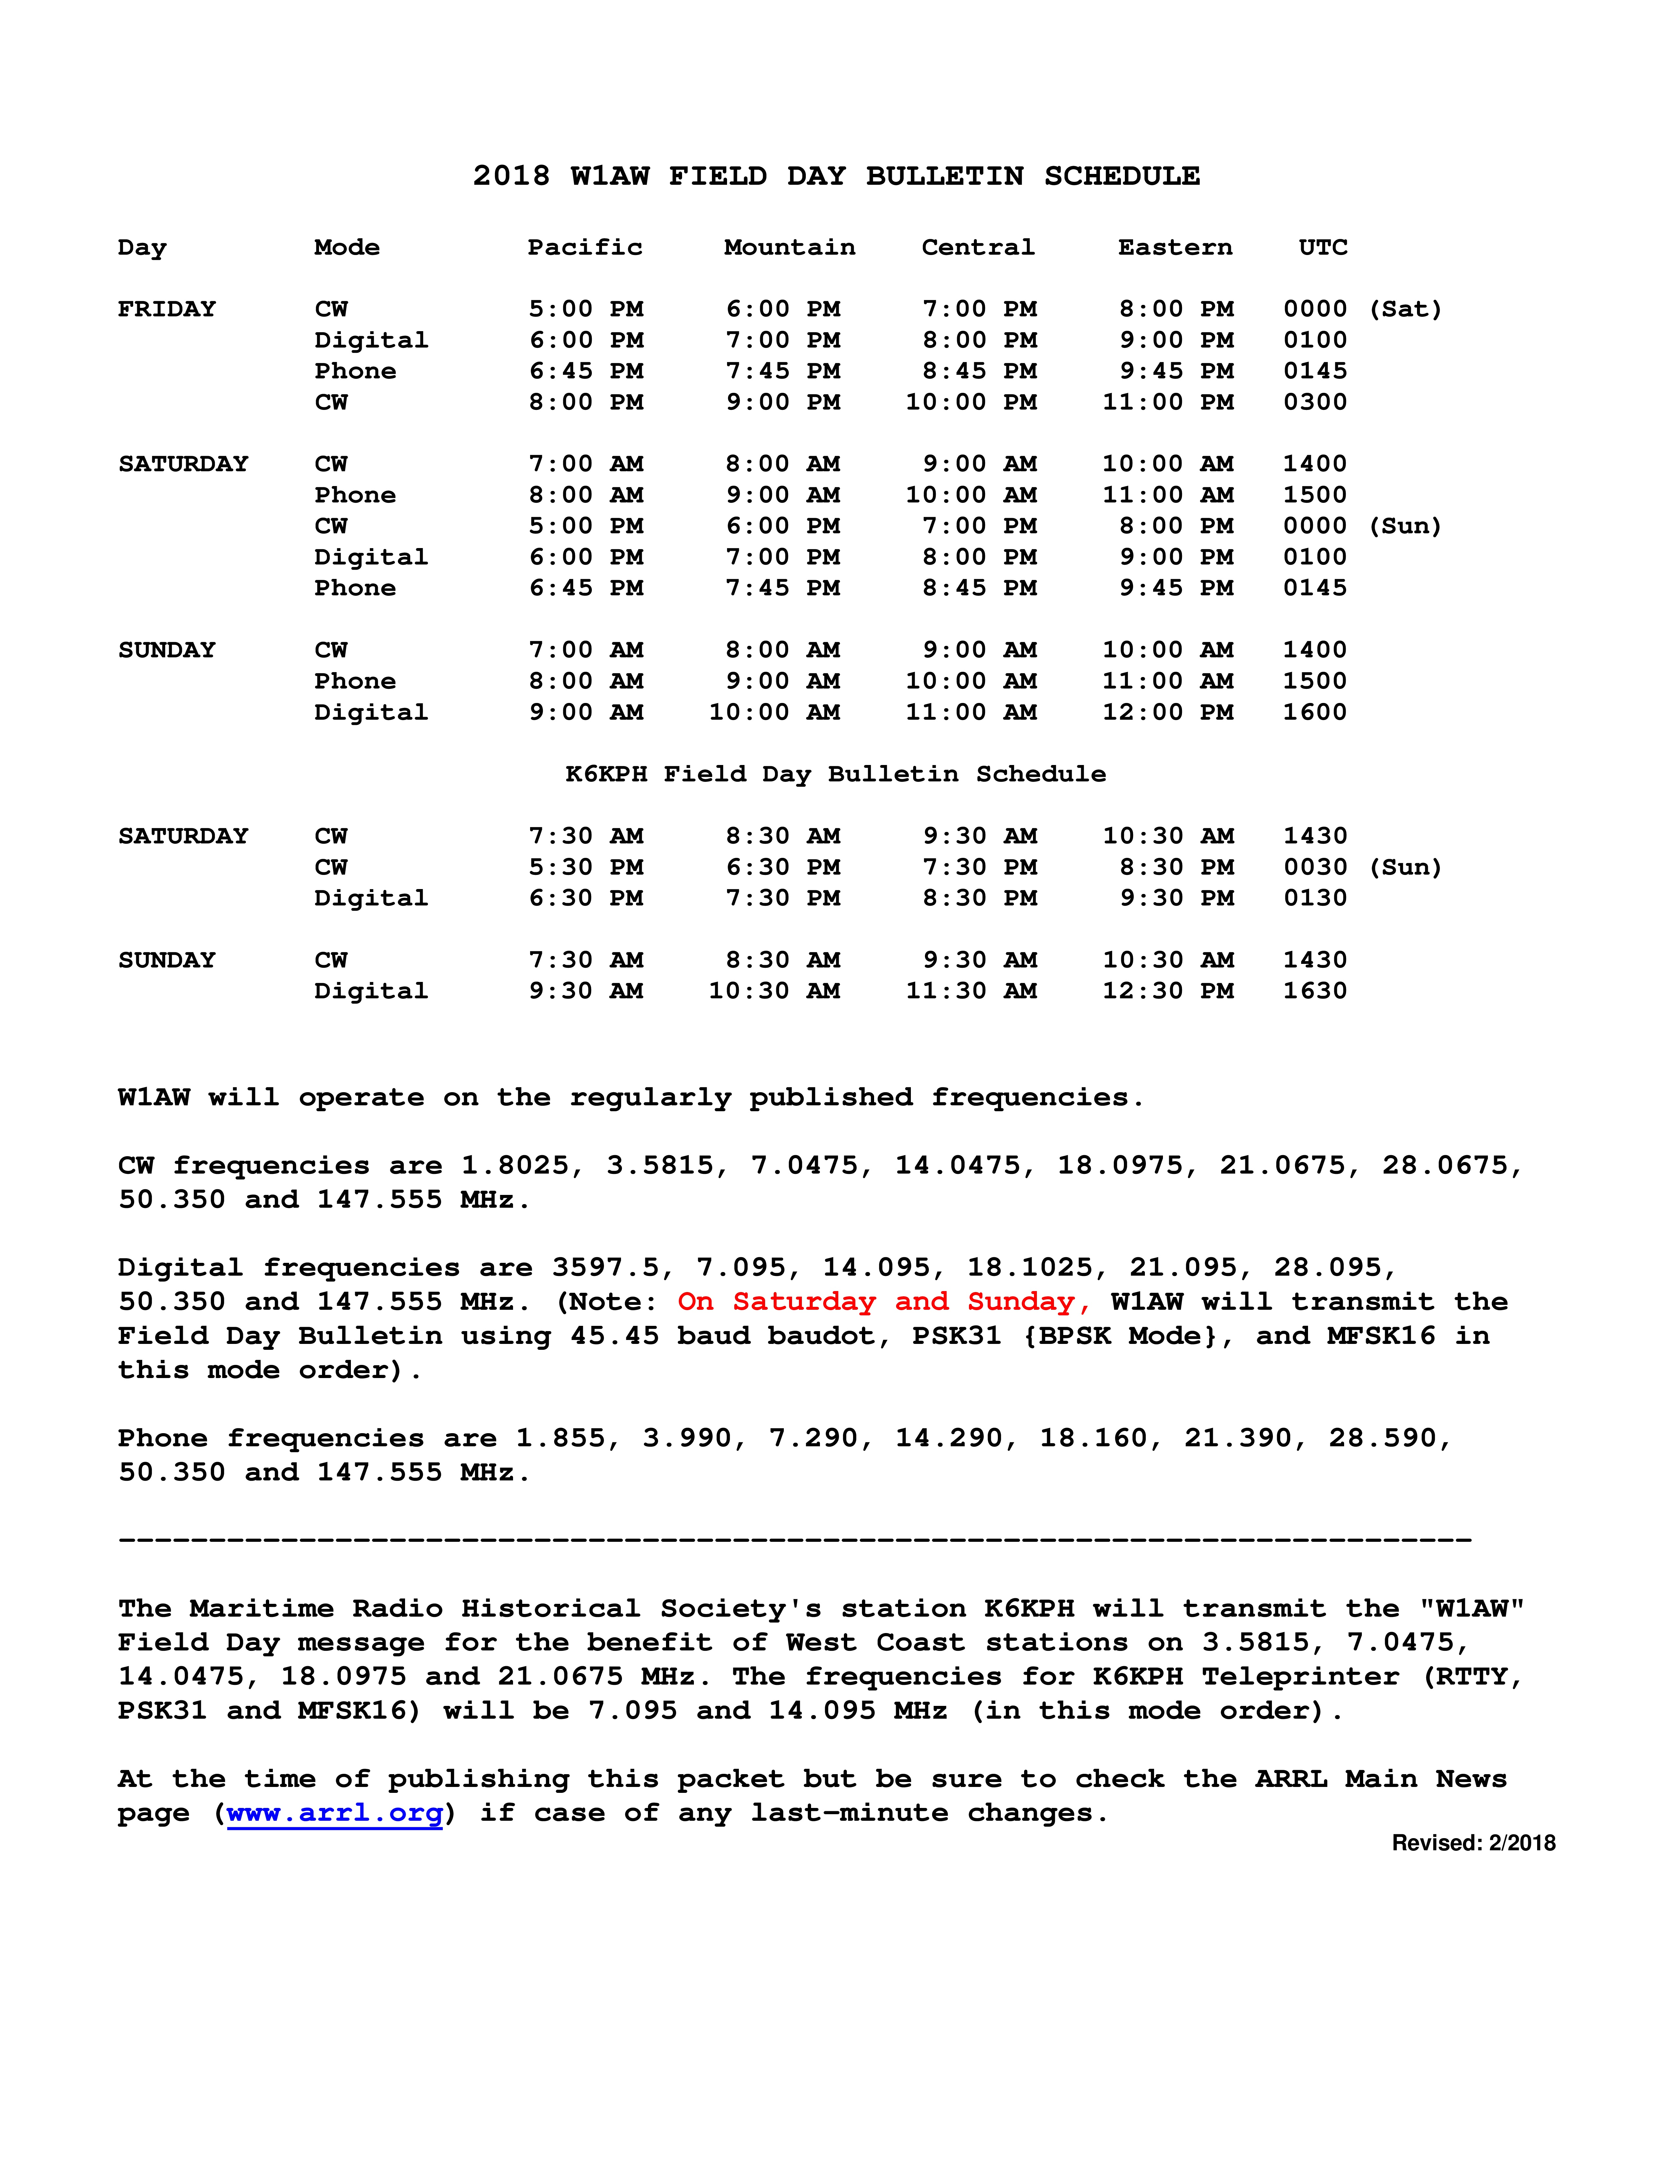



**Communication Calling**

**PHONE - Use phonetics for Call signs and report**

1. CQ CQ Field Day W4CAE

(Whiskey 4 Charlie Alpha Echo)

Call twice then listen for call

2. Respond

(Call Sign) we are 5A SC (Sierra Charlie) QSL?

3. Receive their report Verify Call, Class & Section

4. Log in Logging Program.

**CW/Digital**

1. CQ CQ de W4CAE

2. Send (Call Sign) de W4CAE 5A SC, QSL?

3. Receive their report Verify Call, Class & Section

4. Log in Logging Program.

**Responding to Call**

**PHONE - Use phonetics for Call signs and report**

1. W4CAE (call on QRZ)

(Whiskey 4 Charlie Alpha Echo)

2. Listen for response

3. (Call) this is W4CAE 5A SC(Sierra Charlie) QSL

4. Verify Call and report

5. Log into Logging Program

6. QSL, 73

**CW/Digital**

1. (Call) de W4CAE

2. Send (Call Sign) de W4CAE 5A SC, QSL?

3. Receive their report Verify Call, Class & Section

4. Log in Logging Program.

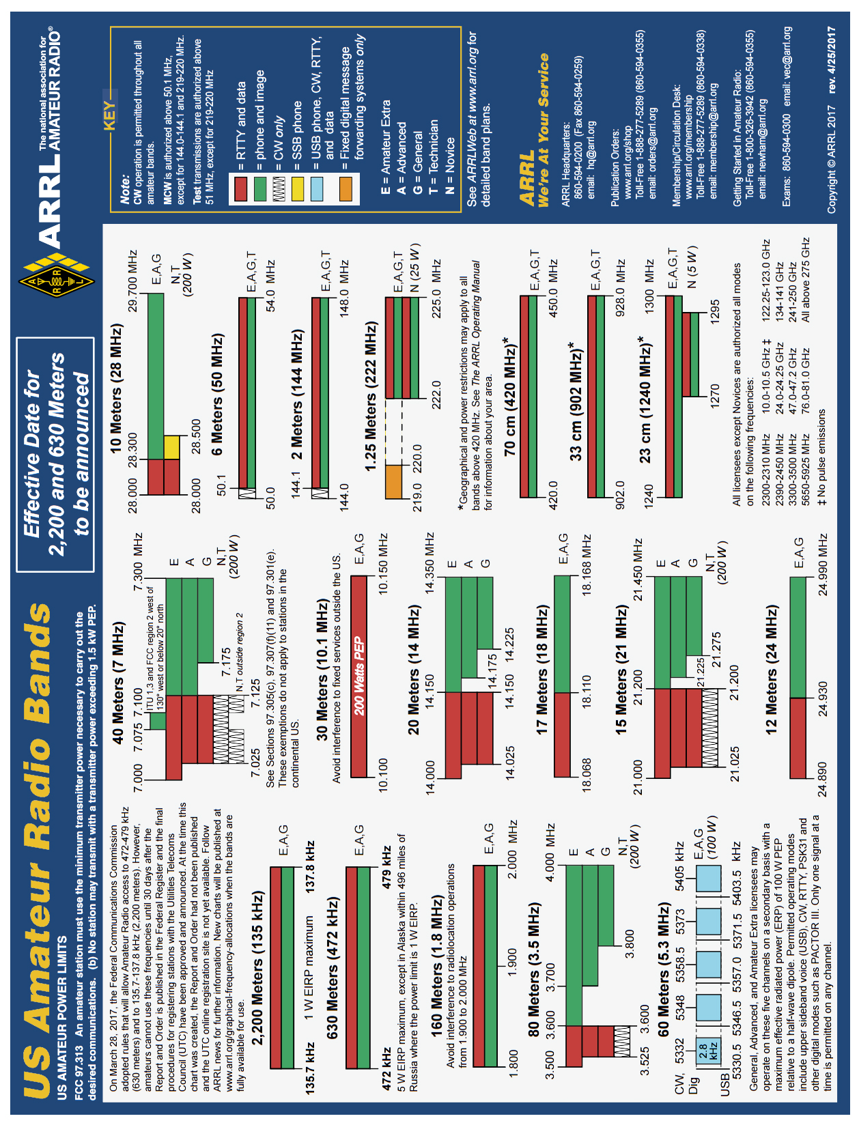

**ARRL Field Day 2018 Rules**

**1. Eligibility:** Field Day is open to all amateurs in the areas covered by the ARRL/RAC Field Organizations and countries within IARU Region 2. DX stations residing in other regions may be contacted for credit, and may submit entries as check-logs.

**2. Object:** To work as many stations as possible on any and all amateur bands

(excluding the 60, 30, 17, and 12-meter bands) and in doing so to learn to operate in abnormal situations in less than optimal conditions. A premium is placed on developing skills to meet the challenges of emergency preparedness as well as to acquaint the general public with the capabilities of Amateur Radio.

**3. Date and Time Period: Field Day 2018 will be held June 23-24.** Field Day is **always the fourth full weekend**,

beginning at 1800 UTC Saturday and ending at 1800 UTC Sunday (or 27 hours for Class A and B if conditions in 3.1.are met).

3.1.Class A and B (see below) stations that do not begin setting up until 1800 UTC on Saturday may operate the entire 27-hour Field Day period.

3.2. Stations who begin setting up before 1800 UTC Saturday may work only 24 consecutive hours, commencing when on-the-air operations begin.

3.3. No class A or B station may begin its set-up earlier than 0000 UTC on the Friday (Thursday afternoon or evening local time) preceding the Field Day period. Cumulative set-up time shall not exceed a total of 24 hours.

**4. Entry Categories:** Field Day entries are classified according to the maximum number of *simultaneously* transmitted signals, followed by a designator indicating the nature of their individual or group participation. The minimum number of transmitters that must be claimed is one (1). Twenty (20) transmitters maximum are eligible for the purpose of calculating bonus points (2,000 points maximum). However, additional transmitters which may legitimately be used simultaneously will determine your entry category classification, but will not earn additional bonus points (i.e. 22 transmitters = 22A). The use of switching systems that allow for lock-outs in order to use multiple transmitters (i.e., an “octopus”) in an attempt to enter a lower-number-of-transmitters class are prohibited (i.e. using 2 transmitters that can transmit simultaneously, with two operators, and a lock-out system and entering class 1A). The use of simulcasting devices which allow a single operator to key and transmit on more than one transmitter at a time, is prohibited. **Bonus stations, such as the GOTA station and satellite station do not count towards determining the number of transmitters for the class and do not qualify for transmitter bonus points.**

**4.1. (Class A) Club / non-club portable:** Club or a non-club group of three or more persons set up specifically for Field Day. Such stations must be located in places that are not regular station locations and must not use facilities installed for permanent station use, or use any structure installed permanently for Field Day. A single licensee or trustee for the entry is responsible for the group entry. All equipment (including antennas) must lie within a circle whose diameter does not exceed 300 meters (1000 feet). To be listed as Class A, all contacts must be

made with transmitter(s) and receiver(s) operating independent of commercial power mains. Entrants whom for any reason operate a transmitter or receiver from a commercial main for one or more contacts will be listed separately as

Class A-Commercial.

**4.1.1. Get-On-The-Air (GOTA) Station**. Any Class A (or F) entry whose transmitter classification is two or more transmitters may also operate one additional station without changing its base entry category, known as the GET-ON-THE-AIR (GOTA) station. **This GOTA station may operate on any Field Day band, HF or VHF, but is limited to one GOTA station transmitted signal at any time.**

4.1.1.1. This station **must use** a different callsign from the primary Field Day station. The GOTA station must use the same callsign for the duration of the event regardless if operators change. **The GOTA station uses the same exchange as its parent.**

4.1.1.2. **The GOTA station may be operated by any person licensed since the previous year’s Field Day, regardless of license class. It may also be operated by a generally inactive licensee. Non-licensed persons may participate under the direct supervision of an appropriate control operator. A list of operators and participants must be included on the required summary sheet to ARRL HQ.**

**4.1.1.3. As per FCC rules, this station must have a valid control operator present at the control point if operating beyond the license privileges of the participant using the station.**

4.1.1.4. The maximum transmitter output power for the GOTA station shall be **150 watts**. If the primary Field Day group is claiming the QRP multiplier level of 5, the maximum transmitter output power of the GOTA station may not exceed 5 watts.

**4.1.1.5. A maximum of 500 QSOs made by this station may be claimed for credit by its primary Field Day operation. In addition, bonus points may be earned by this station under rule 7.3.13.**

**4.1.1.6. The GOTA station may operate on any Field Day band. Only one**

**transmitted signal is allowed from the GOTA station at any time.**

4.1.1.7. The GOTA station does not affect the additional VHF/UHF station provided for under Field Day Rule 4.1.2. for Class A stations.

4.1.1.8. Participants are reminded that non-licensed participants working under the direction of a valid control operator may only communicate with other W/VE stations or with stations in countries with which the US has entered a third-party agreement.

4.1.1.9. The GOTA station does not qualify as an additional transmitter when

determining the number of transmitters eligible for the 100-point emergency power bonus under Rule 7.3.1.

**4.1.2. Free VHF Station: All Class A entries may also operate one additional transmitter if it operates exclusively on any band or combination of bands above 50 MHz (VHF/UHF)**

**without changing its basic entry classification. This station does not qualify for a 100-point bonus as an additional transmitter. This station may be operated for the clubs Field Day period and all contacts count for QSO credit. It is operated using the primary callsign and exchange of the main Field Day group and is separate and distinct from the GOTA station.**

**4.2. (Class A - Battery) Club / non-club portable**: Club or non-club group of three or more persons set up specifically for Field Day. All contacts must be made using an output power of 5 Watts or less **and** the power source must be something other than commercial power mains or motor-driven generator (e.g.: batteries, solar cells, waterdriven generator). Other provisions are the same for regular Class A. Class AB is eligible for a GOTA station if GOTA requirements are met; however if a GOTA station is used in this class it must meet the 5-Watt or less power requirement of this category.

**4.3. (Class B) One or two person portable:** A Field Day station set up and operated by no more than two persons. Other provisions are the same for Class A except it is not eligible for a GOTA or free VHF station. One and two person Class B entries will be listed separately.

**4.4. (Class B - Battery) One or two person portable:** A Field Day station set up and operated by no more than two persons. All contacts must be made using an output power of 5 Watts or less **and** the power source must be something other than commercial mains or motor-driven generator. Other provisions are the same for Class A except it is not eligible for a GOTA or free VHF station. One and two person Class B - Battery entries will be listed separately.

**4.5. (Class C) Mobile:** Stations in vehicles capable of operating while in motion and normally operated in this manner. This includes maritime and aeronautical mobile. If the Class C station is being powered from a car battery or alternator, it qualifies for emergency power but does not qualify for the multiplier of 5, as the

alternator/battery system constitutes a motor-driven generating system.

**4.6. (Class D) Home stations**: Stations operating from permanent or licensed station locations using commercial power. Class D stations may only count contacts made with Class A, B, C, E and F Field Day stations.

**4.7. (Class E) Home stations - Emergency power**: Same as Class D, but using emergency power for transmitters and receivers. Class E may work all Field Day stations.

**4.8. (Class F) Emergency Operations Centers (EOC)**: An amateur radio station at an established EOC activated by a club or non-club group. Class F operation must take place at an established EOC site. Stations may utilize equipment and antennas temporarily or permanently installed at the EOC for the event. Entries will be reported according to number of transmitters in simultaneous operation. Class F stations are eligible for a free VHF station. At Class 2F they are also eligible for a GOTA station.

4.8.1. For Field Day purposes, an Emergency Operations Center (EOC) is defined as a facility established by:

a) a Federal, State, County, City or other Civil Government, agency or administrative entity; or,b) a Chapter of a national or international served agency (such as American Red Cross or Salvation Army) with which your local group has an established operating arrangement;

4.8.1.1. A private company EOC does not qualify for Class F status unless approved by the ARRL Field Day Manager.

4.8.2. Planning of a Class F operation must take place in conjunction and cooperation with the staff of the EOC being activated.

4.8.3. Other provisions not covered are the same as Class A.

4.8.4. A Class F station may claim the emergency power bonus if emergency power is available at the EOC site.

**4.8.4.1. The emergency power source must be tested during the Field Day period but you are not required to run the Class F operation under emergency power.**

5**. Exchange:**

**Stations in ARRL / RAC sections** will exchange their Field Day operating Class and ARRL / RAC section. Example: a three transmitter Class A station in Connecticut which also has a GOTA station and the extra VHF station would send "3A CT" on CW or "3 Alpha Connecticut" on Phone. **DX stations** send operating class and the term DX (i.e. 2A DX).

**6. Miscellaneous Rules:**

6.1. A person may not contact for QSO credit any station from which they also participate.

6.2. A transmitter/receiver/transceiver used to contact one or more Field Day stations may not subsequentlybe used under any other callsign to participate in Field Day. Family stations are exempt provided the subsequent callsign used is issued to and used by a different family member.

6.3. Phone, CW and Digital (non-CW) modes on a band are considered as separate bands. A station may be worked only once per band under this rule.

6.4. All voice contacts are equivalent.

6.5. All non-CW digital contacts are equivalent.

6.6. Cross-band contacts are not permitted (Satellite QSOs cross-band contacts are exempted).

6.7. The use of more than one transmitter at the same time on a single band-mode is prohibited. Exception: a dedicated GOTA station may operate as prescribed in Rule 4.1.

6.8. No repeater contacts are allowed.

6.9. Batteries may be charged while in use. Except for Class D stations, the batteries must be charged from a power source other than commercial power mains. To claim the power multiplier of five, the batteries must be charged from something other than a motor driven generator or commercial mains.

6.10. All stations for a single entry must be operated under one callsign, except when a dedicated GOTA station is operated as provided under Field Day Rule 4.1.1. it uses a single, separate callsign.

**7. Scoring:** Scores are based on the total number of QSO points times the power multiplier corresponding to the highest power level under which any contact was made during the Field Day period plus the bonus points.

**7.1. QSO Points:**

7.1.1. Phone contacts count one point each.

7.1.2. CW contacts count two points each.

7.1.3. Digital contacts count two points each.

**7.2. Power multipliers**: The power multiplier that applies is determined by the highest power output of any of the transmitters used during the Field Day operation.

7.2.1. If all contacts are made using a power of 5 Watts or less ***and*** if a power source other than commercial mains or motor-driven generator is used (batteries, solar cells, water-driven generator), the power multiplier is 5 (five).

7.2.2. If all contacts are made using a power of 5 Watts or less, but the power source is from a commercial main or from a motor-driven generator, the power multiplier is 2. If batteries are charged during the Field Day period using commercial mains or a motor-driven generator the power multiplier is 2 (two).

7.2.3. If any or all contacts are made using an output power up to 150 Watts or less, the power multiplier is 2 (two).

7.2.4. If any or all contacts are made using an output power greater than 150 Watts, the power multiplier is 1 (one).

7.2.5. The power multiplier for an entry is determined by the maximum output power used by any transmitter used to complete any contact during the event. (Example: a group has one QRP station running 3 Watts and a second station running 100 Watts, the power multiplier of 2 applies to all contacts made by the entire operation).

**7.3. Bonus Points: All stations are eligible for certain bonus points, depending on their entry class.**

The following bonus points will be added to the score, after the multiplier is applied, to determine the final Field Day score. Bonus points will be applied only when the claim is made on the summary sheet and any proof required accompanies the entry or is received via email or normal mail delivery.

**7.3.1. 100% Emergency Power**: 100 points per transmitter classification if all contacts are made only using an emergency power source up to a total of 20 transmitters **(maximum 2,000 points.)**

**GOTA station and free VHF Station for Class A and F entries do not qualify for bonus point credit and should not be included in the club’s transmitter total.** All transmitting equipment at the site must operate from a power source completely independent of the commercial power mains to qualify. (Example: a club operating 3 transmitters plus a GOTA station and using 100% emergency power receives 300 bonus points.) **Available to Classes A, B, C, E, and F.**

**7.3.2. Media Publicity**: 100 bonus points may be earned for attempting to obtain publicity from the local media. A copy of the press release, or a copy of the actual media publicity received (newspaper article, etc.) must be submitted to claim the points. **Available to all Classes.**

**7.3.3. Public Location**: 100 bonus points for physically locating the Field Day operation in a public place (i.e. shopping center, park, school campus, etc). The intent is for amateur radio to be on display to the public. **Available to Classes A, B and F.**

**7.3.4. Public Information Table:** 100 bonus points for a Public Information Table at the Field Day site. The purpose is to make appropriate handouts and information available to the visiting public at the site. A copy of a visitor's log, copies of club handouts or photos is sufficient evidence for claiming this bonus. **Available to Classes A, B and F.**

**7.3.5. Message Origination to Section Manager**: 100 bonus points for origination of a formal message to the ARRL Section Manager or Section Emergency Coordinator by your group from its site. You should include the club name, number of participants, Field Day location, and number of ARES operators involved with your station. **The message must be transmitted during the Field Day period and a copy of it must be included in your submission in standard ARRL radiogram or no credit will be given. The message must leave or enter the Field Day operation via amateur radio RF.**

The Section Manager message is separate from the messages handled in Rule 7.3.6. and may not be claimed for bonus points under that rule. **Available to all Classes.**

**7.3.6. Message Handling**: **10 points for each formal message originated, relayed or received and delivered during the Field Day period, up to a maximum of 100 points (ten messages). Copies of each message must be included with the Field Day report. The message to the ARRL SM or SEC under Rule 7.3.5. does not count towards the total of 10 for this bonus.**

**Available to all Classes. All messages claimed for bonus points must leave or enter the Field Day operation via amateur radio RF.**

**7.3.7. Satellite QSO**: 100 bonus points for successfully completing at least one QSO via an amateur radio satellite during the Field Day period. "General Rules for All ARRL Contests" (Rule 3.7.2.), (the no-repeater QSO stipulation) is waived for satellite QSOs. Groups are allowed one dedicated satellite transmitter station without increasing their entry category. Satellite QSOs also count for regular QSO credit. Show them listed separately on the summary sheet as a separate

"band." You do not receive an additional bonus for contacting different satellites, though the additional QSOs may be counted for QSO credit unless prohibited under Rule 7.3.7.1. The QSO must be between two Earth stations through a satellite. **Available to Classes A, B, and F.**

7.3.7.1 Stations are limited to one (1) completed QSO on any single channel FM satellite.

**7.3.8. Alternate Power**: 100 bonus points for Field Day groups making a minimum of five QSOs without using power from commercial mains or petroleum driven generator. This means an "alternate" energy source of power, such as solar, wind, methane or water. This includes batteries charged by natural means (not dry cells). The natural power transmitter counts as an additional transmitter. If you do not wish to increase your operating category, you should take one of your other transmitters off the air while the natural power transmitter is in operation. A separate list of natural power QSOs should be submitted with your entry. **Available to Classes A, B, E, and F.**

**7.3.9. W1AW Bulletin**: 100 bonus points for copying the special Field Day bulletin transmitted by W1AW (or K6KPH) during its operating schedule during the Field Day weekend (listed in this rules announcement). An accurate copy of the message is required to be included in your Field Day submission. (Note: The Field Day bulletin must be copied via amateur radio. It will not be included in Internet bulletins sent out from Headquarters and will not be posted to Internet BBS sites.) **Available to all Classes.**

**7.3.10. Educational activity bonus**: One (1) 100-point bonus may be claimed if your Field Day operation includes a specific educational-related activity. The activity can be diverse and must be related to amateur radio. It must be some type of formal activity. It can be repeated during the Field Day period but only one bonus is earned. For more information consult the FAQ in the complete

Field Day packet. **Available to Classes A & F entries and available clubs or groups operating from a club station in class D and E with 3 or more participants.**

**7.3.11. Site Visitation by an elected governmental official**: One (1) 100-point bonus may be claimed if your Field Day site is visited by an elected government official as the result of an invitation issued by your group. **Available to all Classes.**

**7.3.12. Site Visitation by a representative of an agency**: One (1) 100-point bonus may be claimed if your Field Day site is visited by a representative of an agency served by ARES in your local community (American Red Cross, Salvation Army, local Emergency Management, law enforcement, etc.) as the result of an invitation issued by your group. ARRL officials (SM, SEC, DEC, EC, etc) do not qualify for this bonus. **Available to all Classes.**

**7.3.13. GOTA Bonus.** Class A and F stations operating a GOTA station may earn the following bonus points:

7.3.13.1. When a GOTA operator successfully completes 20 QSOs, they

receive 20 bonus points. Upon reaching an additional 20 QSOs the same operator receives a second 20 bonus points, up to a maximum of 100 Bonus points per GOTA operator. An operator may make more than 100 QSOs but the

QSOs over 100 do not qualify for an additional bonus.

7.3.13.1.1. Additional GOTA operators may earn the GOTA bonus points under

this rule, up to the maximum of 500 bonus points. (Remember that there is a

500-QSO limit for the GOTA station. But no single GOTA operator may earn

more than 100 of the GOTA bonus points except as provided in 7.3.13.2.)

7.3.13.1.2. A single GOTA operator must complete all 20 QSOs required

before the bonus is earned. There is no “partial credit” for making only a portion of the 20 QSOs or “pooling” QSOs between operators.

7.3.13.2. If a GOTA station is supervised full-time by a GOTA Coach, the bonus points earned for each 20 QSOs completed under Rule 7.3.13.1. will be doubled.

7.3.13.2.1. The GOTA Coach supervises the operator of the station, doing such things as answering questions and talking them through contacts, but may not

make QSOs or perform logging functions.

7.3.13.2.2. To qualify for this bonus, there must be a designated GOTA Coach present and supervising the GOTA station at all times it is being operated.

**7.3.14. Web submission:** A 50-point bonus may be claimed by a group submitting their Field Day entry via the www.b4h.net/cabforms web site. **Available to all Classes.**

**7.3.15. Field Day Youth Participation:**

7.3.15.1. A 20-point bonus (maximum of 100) may be earned by any Class A, C, D, E, or F group for each participant age 18 or younger at your Field Day operation that completes at least one QSO.

7.3.15.2. For a 1-person Class B station, a 20-point bonus is earned if the operator is age 18 or younger. For a 2-person Class B station, a 20-point bonus is earned for each operator age 18 or younger (maximum of 40 points.) Keep in mind that Class B is only a 1 or 2 person operation. This bonus does not allow the total number of participants in Class B to exceed 1 or 2.

**7.3.16 Social Media: 100 points for promoting your Field Day activation to the general public via an active, recognized and utilized social media platform (Facebook, Twitter, Instagram, etc). This bonus is available to bona fide Amateur Radio clubs and Field Day groups that welcome visitors to their operation. Individual participants do not qualify for this bonus. Club websites do not qualify for this bonus. Available to all classes.**

**7.3.17 Safety Officer Bonus: A 100-point bonus may be earned by having a person serving as a Safety Officer for those groups setting up Class A stations. This person must verify that all safety concerns on the Safety Check List (found in the ARRL Field Day Packet) have been adequately met. This is an active bonus – simply designating someone as Safety Officer does not automatically earn this bonus. A statement verifying the completion of the Safety Check List must be included in the supporting documentation sent to ARRL HQ in order to claim this bonus.**

**8. Reporting:**

**8.1. Entries may be submitted to the ARRL in one of three ways:**

**8.1.1. Via Field Day Web Submission Applet site at www.b4h.net/cabforms/;**

**8.1.2. Via email to fieldday@arrl.org; or**

**8.1.3. Via land postal or delivery service to Field Day Entries, 225 Main St, Newington, CT 06111.**

**8.2. Entries must be postmarked, emailed or submitted by Tuesday July 24, 2018. Late entries cannot be accepted.**

8.3. A complete Field Day Web Applet Submission site entry consists of:

8.3.1. An official ARRL summary sheet which is completed on the site;

8.3.2. Supporting information must be emailed to fieldday@arrl.org or submitted by land service. Supporting information must include:

8.3.2.1. An attached list of stations worked by band/mode during the Field Day period (dupe sheet or an alpha/numeric list sorted by band and mode); and

8.3.2.2. Proof of all bonus points claimed (copies of visitor logs, press releases, NTS messages handled, photographs, etc).

8.4. A complete non-applet email submission consists of:

8.4.1. An electronic copy of an ARRL summary sheet completely and accurately filled out;

8.4.2. An attached list of stations worked by band/mode during the Field Day period (dupe sheet or an alpha/numeric list sorted by band and mode); and

8.4.3. Proofs of bonus points claimed (copies of visitor logs, press releases, NTS messages handled, photographs, etc).

8.5. A complete land postal or delivery non-electronic submission consists of:

8.5.1. A complete and accurate ARRL summary sheet;

8.5.2. An accompanying list of stations worked by band/mode during the Field Day period (dupe sheet or an alpha/numeric list sorted by band and mode); and

8.5.3. Proofs of bonus points claimed (copies of visitor logs, press releases, NTS messages handled, photographs, etc).

**8.6. Complete station logs are not required for submission. The club should maintain log files for one year in case they are requested by ARRL HQ.**

**8.7. Cabrillo format log files are not required for Field Day entries. They will be accepted in lieu of the dupe sheets but do not constitute an entry unless a corresponding summary sheet is also submitted.**

8.8. Digital images of proof of bonus points are acceptable.

8.9. Electronic submissions are considered signed when submitted.

**9. Miscellaneous:**

9.1. The schedule of bulletin times for W1AW is included in this announcement. While W1AW does not have regular bulletins on weekends, the Field Day message will be sent according to the schedule included with this

announcement. The W1AW bulletins will be transmitted on the regular W1AW frequencies listed in *QST*. The PSK31 bulletin will be transmitted on the W1AW teleprinter frequencies. The special Field Day bulletin will be transmitted from station K6KPH on the West Coast as included in the bulletin schedule.

9.2. See "General Rules for All ARRL Contests," "General Rules for All ARRL Contests on Bands Below 30 MHz," and "General Rules for All ARRL Contests on Bands Above 50 MHz" for additional rules (www.arrl.org/contest-rules) that may cover situations not covered in these Field Day rules. Decisions of the ARRL Awards Committee are final in adjudicating Field Day problems.

9.3. **The complete Field Day information package may be obtained by:**

**9.3.1. Sending a SASE with 5 units of postage to: Field Day Information Package, ARRL, 225 Main St., Newington, CT 06111; or**

**9.3.2. By downloading from the Contest Branch home page at: www.arrl.org/field-day**

9.4. For more Field Day information/questions contact: fdinfo@arrl.org or phone (860) 594-0232. (revised: February 2018)